* Project description, problem definition:

**Context:** Playing video games is an activity that can require a wider range of mobility thanks to various controller types like Xbox controllers, or Racing wheels enhancing player experiences.

**Issues:** However, not all people, and not all players have the physical capability to fully utilise the input device to its fullest potential.

**Relevance:** This can cause players to struggle to play certain games, and in certain cases make it impossible or nearly impossible to play the desired game using traditional input devices.

**Objective:** In this project we will be constructing a controller with an aim to allow players with more limited motor functionality to play more of these games that were previously inaccessible, and improve their experiences playing games they may have previously struggled with.

**Existing solutions:** There are a number of ways that can be implemented to solve the accessibility problem, and there are various available on the market today, such as the Gypard, and many 3D print options such as one where it makes one of the analog sticks accessible in the rear of the controller.

<https://gypard.com/>

<https://www.notebookcheck.net/3D-printed-PlayStation-controller-mod-allows-one-handed-PS4-and-PS5-gaming.597669.0.html>

**To ask about how viable out ideas are, we asked 6 people some questions:**

**Questions:**

Have you ever used a one-handed controller before (wii remote, vr controller)?

What do you expect from a one-handed controller?

Here are some ideas: etc.

**We also engaged in discussions with a few of them:**

**Pedals sound good, tho consider, Mouth controller (blowtubes** [**https://www.quadstick.com/**](https://www.quadstick.com/)**)**

**Extra latency**

**Palm grip: though how do you put it on, wrist as alternative**

**Turbo does have effect an effect on the game experience**

**Layout Shift button - only some keys, gyro enable and disable?**

**Context stuff**

**Project Description**

**Definition**

Playing video games is an activity that can require a wider range of mobility thanks to the various controller types, like Xbox controllers or Racing wheels, that enhance player experiences. However, not all people, and not all players have the physical capability to fully utilise the input device to its fullest potential. This can result in these players unable to enjoy and play certain games, and in some cases make it impossible or nearly impossible to play the desired game using traditional input devices.

There are a number of tools that can be utilized to mitigate the problem, and various are available on the market today, such as the Gypard and multiple 3D print options, like one that connects one of the analog sticks to another on the rear of the controller, allowing the player to use any surface, such as their thigh to operate one of the analog sticks.

The techniques others have come up with to increase usability are diverse, and include making the controller hardware customizable, like with the Xbox Adaptive Controller and a patented flat controller concept (patent expired) that puts the various inputs within a finger’s reach. Both require being placed on a stable surface to be used properly though, and this makes them not very portable.

In this project, we will be constructing a controller with a goal to allow players with more limited motor functionality to play and enjoy more of the games that were previously inaccessible, and improve their experiences playing them. We will aim to create a handheld design so that people aren’t required to use a table or other flat surface.

**Justification**

If this problem is not solved, a number of people will remain unable to play and enjoy video games in a comfortable and fun manner. This problem affects people who cannot use two hands playing games that require two. They can be either born this way or lost the hand or function because of an accident.

This problem isn’t specific to just video games, accessibility is a topic discussed in most industries, and many people have attempted solutions in their specific contexts. Not only this, but statistics show that over 3 million people in the USA alone do not have 2 fully functioning hands, which shows just how large of a population could be encountering issues.This does mean that the market for tools that can be used with one hand become important. One example is the JoyKey, it attempts to create a one-handed keyboard for katakana by utilizing flick input keys (joysticks), it is also multipurpose and can be used as a controller (though not effectively one-handed). Another tool is an adaptor for two-handed instruments, such as one for a bass guitar that controls the frets using a foot controller, while allowing the musician to strum with their hand.

**Ideation**

Design Think

**Interview & Digging deeper**

We interviewed 6 people about using one-handed controllers. (see appendix for the questions asked)

All six interviewees had used a one-handed controller before, typically a Wii remote and a few had used a VR controller. All of them had positive things to say about the controllers, but criticized their lack of usability for all games. For example: the Wii remote is only one-handed in specific games/contexts. One person also noted that extended use of a one-handed controller can cause cramping.

When asked about what they expected out of a one-handed controller, all of the interviewees were very unanimous with their thoughts. All of them noted that it had to be comfortable to hold and ergonomic. They also thought that the buttons had to be easily accessible without having to reach or strain their hand to access vital controls.

The questions we asked were:

* Have you used a one-handed controller before (VR, Wiimote, etc.)? How did you feel about that experience?
* What do you expect from a one-handed controller?
* Some of the ideas we have for solutions regarding one-handed controllers include:
  + Shift button to reduce the number of total buttons
  + Attachments like foot pedals
  + Gyro to replace directional input
  + Utilizing your palm's grip for an input
  + Turbo and button lock systems
* What are your thoughts on our ideas?

**Reframe the problem**

Looking through the history of one-handed controllers, there were many different designs, approaches and intentions over the years. Some of the earliest ones were made for the Nintendo Famicom with the purpose of being used not for people with one hand, but rather for RPG games specifically. Much later, controllers were made with the sole purpose of accessibility and inclusion. In 1991, a controller was made for non-analog PS1 games that utilized remappable back buttons to make it more effective and customizable. In 2016, a controller was made that utilized a SHIFT button to swap what the joystick would do. It would cycle between the left stick, right stick and the d-pad. In more recent years, such as 2017, 3D printing your own snap on controller add-ons would become more widespread. This would make it easier to share ideas without the need to manufacture and sell them. In 2018, Microsoft would release the Xbox adaptive controller which was compatible with many other devices which allowed users to create their own set ups to suit their needs more specifically.

**Ideate**

To think of solutions, we discussed within our group and utilized our interview results and research to create these 3 concepts:

1. Controller with one joystick that can be shifted using a layout shift button. It will also have 4 face buttons (a,b,x,y), 2 bumpers, 2 triggers, and the shift button on the back of the controller.
2. Controller with one joystick and gyro that can be disabled through use of an external input (pedal, grip, etc.) to replace the other joystick. All the standard buttons would be on the back of the controller.
3. Controller with a squeeze input that would be used as a layout shift button, similar to idea 1 but with different button placement and a strap to keep the controller in the hand without requiring it to be gripped, making the input possible

**Feedback**

We then discussed with 3 of the interviewees their opinions of the features created above (see appendix for the list of potential features). The use of turbo buttons was widely considered useful. Gyro controls were thought to be useful, but to a point and difficult to perfect. The shift button was also thought to be useful but with some concern over complexity. The pedals were considered useful but a little unnecessary. No one really liked the palm grip as players may grip unintentionally during tense sections of games and it would be difficult to learn. Utilizing this feedback and previous information, we created a final concept.

**Proposed Concept**

The features that were deemed most important were considered when designing the controller.

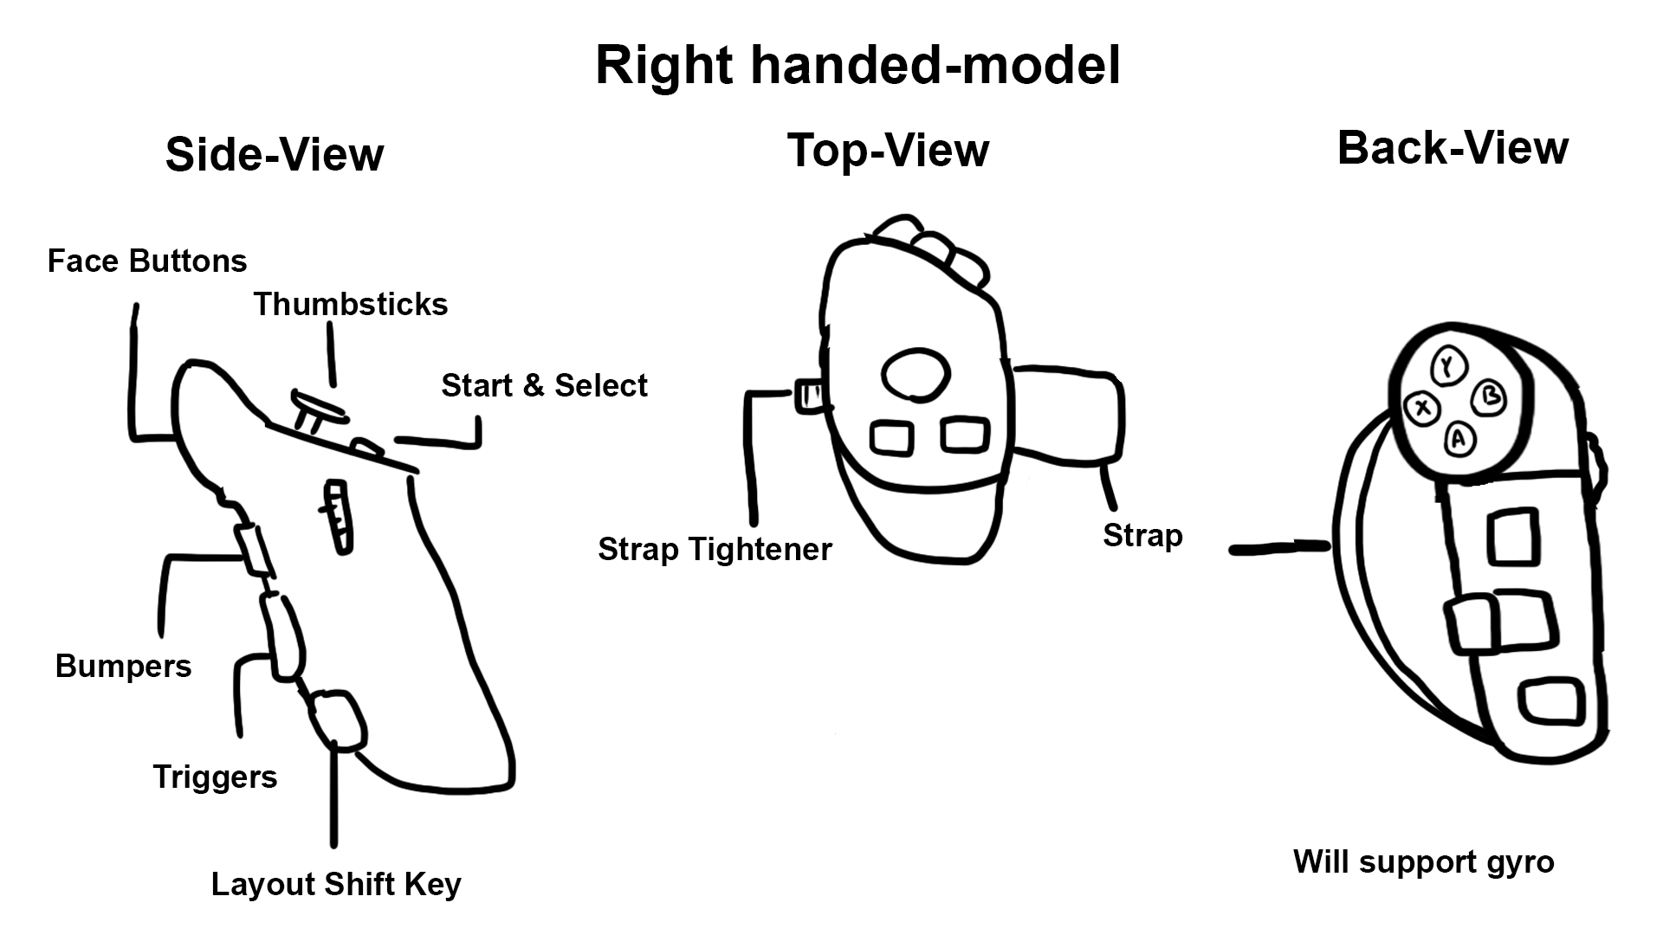

As seen in Fig. 1, the controller utilizes a vertical grip shape and a strap to hold it against the upper palm, making it harder to drop. The strap is tightened using a gear on the side to make it easier to put on with one hand. At the top of the controller is a joystick and the two menu buttons, on the back is the rest of the inputs. Going downwards, there are the 4 face buttons, the 2 bumpers imputed through a single tilt button, the two triggers side by side, and the shift button that is held when layout shifting.

Layout shifting changes the face buttons into d-pad inputs and activate the gyro for right-stick

**System Architecture**

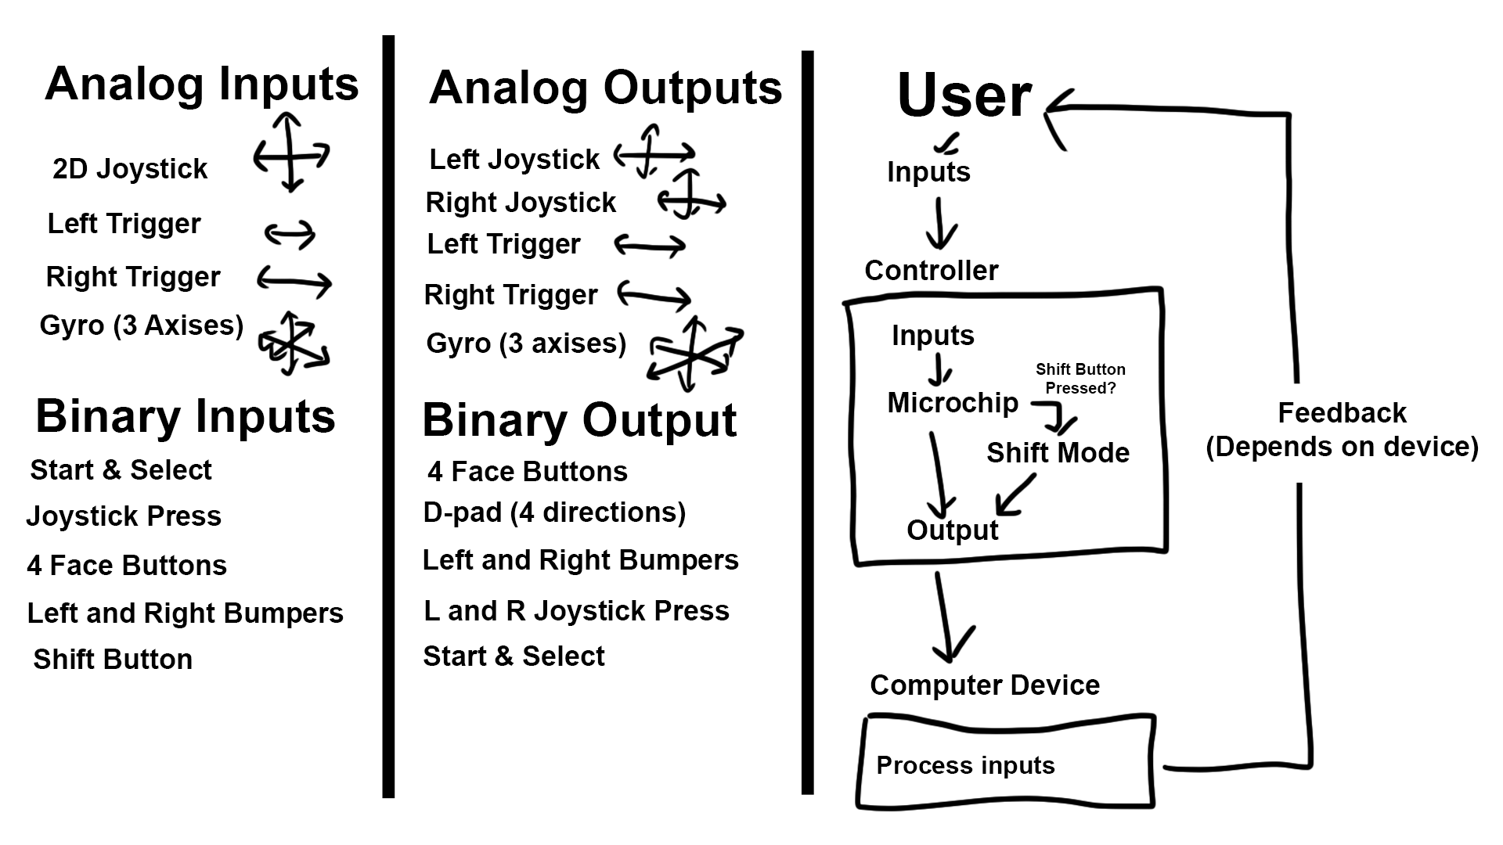

As seen in Fig. 2, our controller outputs computer readable controller inputs, and takes in less inputs that it outputs. The shift button is the reason for this and is what is used to decide how the other inputs are read and passed through to the computer. This extra step is what allows the controller to output more values than its inputs.

**Product Comparison**

Timeline of One Handed Controllers:

Source: <https://www.oneswitch.org.uk/OS-REPOSITORY/MUSEUM/VARIOUS/CONTROLLERS/ONE-HANDED/ONE-HANDED-GAMING.pdf>

1983: Nintendo Famicom Gamepad is created for one handed play.

1989: Ultech Mejin-kun one-hand joystick adapter and ASCII L5 one-hand controller created for RPG and Strategy games specifically.

1997: ASCII created several one-handed controllers for the PS1 for pre analog games. They even had 2 **remappable back buttons**

2000: Dragonplus RPG ambidextrous controller was released

2006: Nintendo launches the Wii with the Wii remote controller that was used one handed for many games. Unfortunately this was not universal for games that require a Wii nunchuck attachment.

2006: Ben Heck (American Engineer) creates a one-handed controller for the Xbox 360.

2007: Iphone releases with mobile games that commonly only required one thumb to play.

2008: Ben Heck designs the eDimensional Access Controller and releases it for the PS2, PS3 and PC. This wireless controller had swappable control modules.

2010: Evil Controllers sells one-handed controllers in America.

2016: OneSwitch creates a method of converting a PS3 into a one handed controller that has a **SHIFT button** to change joystick modes.

2017: Julio “Vexelius” Vasquez creates a **3D printed** joiner to make 2 switch JoyCons usable with one hand.

**2018: Xbox releases the Xbox Adaptive Controller.**

2021-2022: Akaki Kuumeri creates advanced 3D printed, **snap-on devices** to make PS4, PS5, and Xbox controllers one-handed.

**Planning**

Organized using a Trello board:

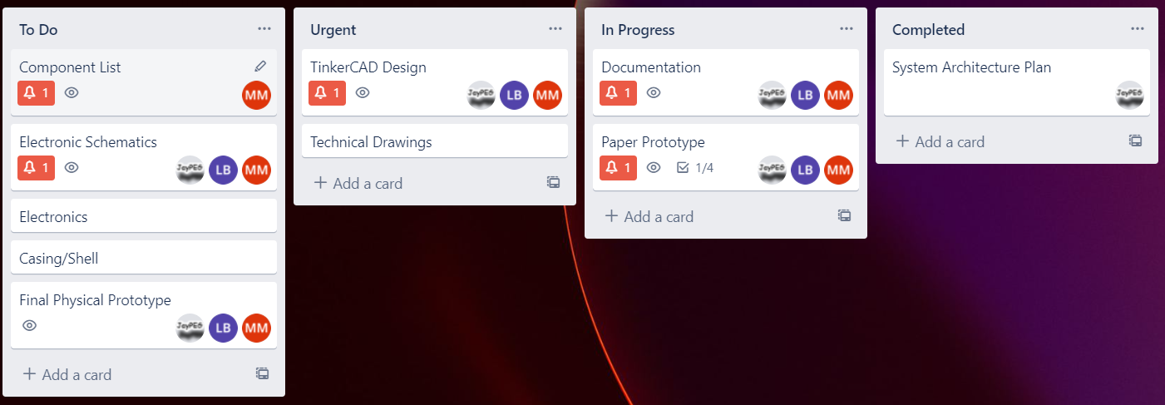

**Sources**

<https://gypard.com/>

<https://www.notebookcheck.net/3D-printed-PlayStation-controller-mod-allows-one-handed-PS4-and-PS5-gaming.597669.0.html>

<https://www.oneswitch.org.uk/OS-REPOSITORY/MUSEUM/VARIOUS/CONTROLLERS/ONE-HANDED/ONE-HANDED-GAMING.pdf>

<https://www.ishn.com/articles/97844-statistics-on-hand-and-arm-loss>

<https://patents.google.com/patent/US20090054146A1/en>

JoyKey

<https://link.springer.com/chapter/10.1007/978-3-319-58521-5_21>

Guitar

<https://www.researchgate.net/profile/Jacob-Harrison/publication/325651424_An_Adapted_Bass_Guitar_for_One-Handed_Playing/links/5b1a8bb3a6fdcca67b67050b/An-Adapted-Bass-Guitar-for-One-Handed-Playing.pdf>

***Gypard one-handed controller*. Gypard. (n.d.). Retrieved September 28, 2022, from https://gypard.com/**

**ISHN. (2014, January 28). *Statistics on hand and arm loss*. ISHN RSS. Retrieved September 28, 2022, from https://www.ishn.com/articles/97844-statistics-on-hand-and-arm-loss**

***One handed gaming - oneswitch.org.uk*. (n.d.). Retrieved September 28, 2022, from https://www.oneswitch.org.uk/OS-REPOSITORY/MUSEUM/VARIOUS/CONTROLLERS/ONE-HANDED/ONE-HANDED-GAMING.pdf**

**Zlatev, D. (2022, February 4). *3D-printed PlayStation controller mod allows one-handed PS4 and PS5 gaming*. Notebookcheck. Retrieved September 28, 2022, from https://www.notebookcheck.net/3D-printed-PlayStation-controller-mod-allows-one-handed-PS4-and-PS5-gaming.597669.0.html**

**Harrison, Jacob, and Andrew P. McPherson. “Adapting the Bass Guitar for One-Handed Playing.” *Journal of New Music Research*, vol. 46, no. 3, 2017, pp. 270–285.,** [**https://doi.org/10.1080/09298215.2017.1340485**](https://doi.org/10.1080/09298215.2017.1340485)**.**

**Shizuki, Buntarou, and Shin Takahashi. “JoyKey: One-Handed Hardware Keyboard with 4x3 Grid Slide Keys.” *Human Interface and the Management of Information: Information, Knowledge and Interaction Design*, 18 May 2017, pp. 266–279., https://doi.org/10.1007/978-3-319-58521-5_21.**